FORTH ASSIGMENT IN IN INTRENSHIP

MACHINE LEARNING

1. Which of the following methods do we use to find the best fit line for data in Linear Regression?

A) Least Square Error B) Maximum Likelihood

C) Logarithmic Loss D) Both A and B

ANS:- A) Least Square Error

2. Which of the following statement is true about outliers in linear regression?

A) Linear regression is sensitive to outliers B) linear regression is not sensitive to outliers

C) Can’t say D) none of these

ANS:- A) Linear regression is sensitive to outliers

3. A line falls from left to right if a slope is ______?

A) Positive B) Negative

C) Zero D) Undefined

ANS:- B) Negative

4. Which of the following will have symmetric relation between dependent variable and independent variable?

A) Regression B) Correlation

C) Both of them D) None of these

ANS:- C) Both of them

5. Which of the following is the reason for over fitting condition?

A) High bias and high variance B) Low bias and low variance

C) Low bias and high variance D) none of these

ANS:- C) Low bias and high variance

6. If output involves label then that model is called as:

A) Descriptive model B) Predictive modal

C) Reinforcement learning D) All of the above

ANS:- C) Reinforcement learning

7. Lasso and Ridge regression techniques belong to _________?

A) Cross validation B) Removing outliers

C) SMOTE D) Regularization

ANS:- D) Regularization

8. To overcome with imbalance dataset which technique can be used?

A) Cross validation B) Regularization

C) Kernel D)SMOTE

ANS:- D) SMOTE

9. The AUC Receiver Operator Characteristic (AUCROC) curve is an evaluation metric for binary classification problems. It uses _____ to make graph?

A) TPR and FPR B) Sensitivity and precision

C) Sensitivity and Specificity D) Recall and precision

ANS:- A) TPR and FPR

10. In AUC Receiver Operator Characteristic (AUCROC) curve for the better model area under the curve should be less.

A) True B) False

Ans:- B) False

11. Pick the feature extraction from below:

A) Construction bag of words from a email B) Apply PCA to project high dimensional data

C) Removing stop words D) Forward selection

ANS:- B) Apply PCA to project high dimensional data

12. Which of the following is true about Normal Equation used to compute the coefficient of the Linear Regression?

A) We don’t have to choose the learning rate.

B) It becomes slow when number of features is very large.

C) We need to iterate.

D) It does not make use of dependent variable.

ANS:-A,B and C

13. Explain the term regularization?

:-Regularization concepts of Machine Learning important concepts of Machine Learning.

:-It is a technique to prevent the model from overfitting by adding extra information to it.

:-Regularization is that will try to apply some kind of pently

(PENTLY MEANS LAMBDA)

:-Regularization two part L1=LASSO

L2=RIDGE

14. Which particular algorithms are used for regularization?

:- Regularization two part L1=LASSO

L2=RIDGE

-LASSO(L1):-Omit Certain Attributes.

Y=a+b1x1+b2x2…bnxn

-RIDGE(L2):-reduce down the cofficent diffirences.

Alpha=.0001

Point:-1. Y=a+b1x1+b2x2…bnxn 2. Alpha=.0001

:-Point 1 and 2 is Elastic Net

Dipply explain L1 and L2

L1(LASSO).

f1,f2,f3🡨 Label

:-L1 is completely vanish.

:-not contributing much to pridect.

:-f1 dosen’t exist data set so it will is 0.

:-L1 is completely elimant is a physically but it’s a given important zero.

:-Lasso will return best alpha and cofficients after perfoming 10 cross validations.

L2 (RIDGE).

f1, f2,f3🡨 this is label.

:-suppose that if f1 feature is not contributing much to predict the level.

:-f1 is a very less importance to give.

15. Explain the term error present in linear regression equation?

:- An error term is a residual variable produced by a statistical or mathematical model, which is created when the model does not fully represent the actual relationship between the independent variables and the dependent variables.

:- As a result of this incomplete relationship, the error term is the amount at which the equation may differ during empirical analysis.

Formula:-

​*Y*=*αX*+*βρ*+*ϵ***where:***α*,*β*=Constant parameters*X*,*ρ*=Independent variables*ϵ*=Error term>

PYTHON – WORKSHEET 1

1. Which of the following operators is used to calculate remainder in a division?

A)# B) & C) % D) $

ANS:- C) %

2. In python 2//3 is equal to?

A) 0.666 B) 0 C) 1 D) 0.67

ANS:-B)0

3.In python, 6<<2 is equal to?

A)36 B)10 C)24 D)45

ANS:-C)24

4. In python, 6&2 will give which of the following as output?

A) 2 B) True C) False D) 0

ANS:-A)2

5. In python, 6|2 will give which of the following as output?

A) 2 B)4 C) 0 D) 6

ANS:-D)6

6. What does the finally keyword denotes in python?

A) It is used to mark the end of the code

B) It encloses the lines of code which will be executed if any error occurs while executing the lines of code in the try block.

C) the finally block will be executed no matter if the try block raises an error or not.

D) None of the above

ANS:- C) the finally block will be executed no matter if the try block raises an error or not.

7. What does raise keyword is used for in python?

A) It is used to raise an exception.

B) It is used to define lambda function

C) it's not a keyword in python.

D) None of the above

ANS:- A) It is used to raise an exception.

8. Which of the following is a common use case of yield keyword in python?

A) in defining an iterator

B) while defining a lambda function

C) in defining a generator

D) in for loop

ANS:- C) in defining a generator

9. Which of the following are the valid variable names?

A) _abc B) 1abc C) abc2 D) None of the above

ANS:-A,B AND C

10. Which of the following are the keywords in python?

A) yield B) raise C) look-in D) all of the above

ANS:-A and B

11. Write a python program to find the factorial of a number.

**What is factorial?**

Factorial is a non-negative integer. It is the product of all positive integers less than or equal to that number you ask for factorial. It is denoted by an exclamation sign (!).

EXAMPLE 1.

# Python program to find the factorial of a number provided by the user.

# change the value for a different result

num = 7

# To take input from the user

#num = int(input("Enter a number: "))

factorial = 1

# check if the number is negative, positive or zero

if num < 0:

print("Sorry, factorial does not exist for negative numbers")

elif num == 0:

print("The factorial of 0 is 1")

else:

for i in range(1,num + 1):

factorial = factorial*i

print("The factorial of",num,"is",factorial)

RUN

The factorial of 7 is 5040.

12. Write a python program to find whether a number is prime or composite.

**What is Prime number?**

Any natural number that is divisible by 1 and itself called Prime Number in Python. Prime number is not divisible by any other numbers except one and itself.

**Prime Numbers** are 2, 3, 5, 7, 11, 13, 17, 19, 23, 29, 31, 37, 41, 43, 47, 53, 59, 61, 67, 71, 73, 79, 83, 89, 97, 101, 103, 107, 109 etc

## What is composite number?

Any positive integer that can be formed by multiplying two smaller positive integers is called composite number. In other word, Composite number is a positive integer that has at least one divisor other than 1 and itself.

We can say that composite numbers are exactly the numbers that are not prime and not a unit.

**Composite numbers** are 4, 6, 8, 9, 10, 12, 14, 15, 16, 18, 20, 21, 22, 24, 25, 26, 27, 28, 30, 32, 33, 34, 35, 36, 38, 39, 40, 42, 44, 45, 46, 48, 49, 50, 51, 52, 54, 55, 56, 57, 58, 60, 62, 63, 64, 65, 66, 68, 69, 70, 72, 74, 75, 76, 77, 78, 80, 81, 82, 84, 85, 86, 87, 88, 90, 91, 92, 93, 94, 95, 96, 98, 99, 100, 102, 104, 105, 106, 108, 110, 111, 112, 114, 115, 116, 117, 118, 119, 120, 121, 122, 123, 124, 125, 126, 128, 129, 130, 132, 133, 134, 135, 136, 138, 140, 141, 142, 143, 144, 145, 146, 147, 148, 150 etc.

# Program to check if a number is prime or not

EXAMPLE 1

num = 29

# To take input from the user

#num = int(input("Enter a number: "))

# define a flag variable

flag = False

if num == 1:

print(num, "is not a prime number")

elif num > 1:

# check for factors

for i in range(2, num):

if (num % i) == 0:

# if factor is found, set flag to True

flag = True

# break out of loop

break

# check if flag is True

if flag:

print(num, "is not a prime number")

else:

print(num, "is a prime number")

RUN

29 is a prime number >.

EXAMPLE 2

num = 407

# To take input from the user

#num = int(input("Enter a number: "))

if num == 1:

print(num, "is not a prime number")

elif num > 1:

# check for factors

for i in range(2,num):

if (num % i) == 0:

print(num,"is not a prime number")

print(i,"times",num//i,"is",num)

break

else:

print(num,"is a prime number")

# if input number is less than

# or equal to 1, it is not prime

else:

print(num,"is not a prime number")

RUN

407 is not a prime number

11 times 37 is 407

13. Write a python program to check whether a given string is palindrome or not.

Given a string, write a python function to check if it is palindrome or not. A string is said to be a palindrome if the reverse of the string is the same as the string. For example, “radar” is a palindrome, but “radix” is not a palindrome.

**Examples:**

**Input :** malayalam

**Output :** Yes

**Input :** geeks

**Output :** No

EXAMPLE:-

|  |
| --- |
| # function to check string is  # palindrome or not  **def** isPalindrome(s):        # Using predefined function to      # reverse to string print(s)      rev **=** ''.join(reversed(s))        # Checking if both string are      # equal or not  **if** (s **==** rev):  **return** True  **return** False    # main function  s **=** "malayalam"  ans **=** isPalindrome(s)    **if** (ans):      print("Yes")  **else**:  **print**("No") |

**Output**

Yes

14. Write a Python program to get the third side of right-angled triangle from two given sides.

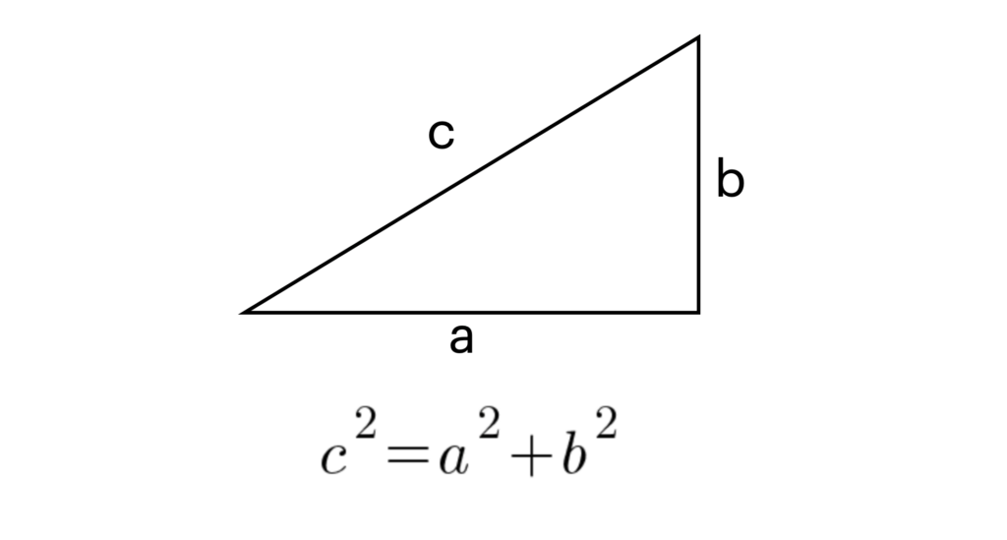

The Pythagorean theorem states that given a right triangle, the **hypotenuse squared equals the sum of the sides squared**.

Here is an example.

Given sides **a = 3** and **b = 4** in a right triangle, what is the length of the hypotenuse?

**The solution:**

Here is an example.

Given sides **a = 3** and **b = 4** in a right triangle, what is the length of the hypotenuse?

**The solution:**

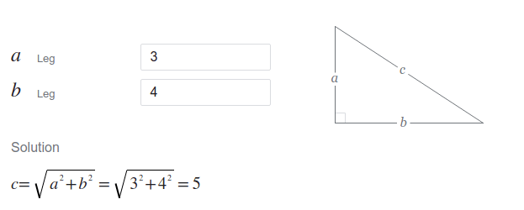

Here is the code:

import math

a = 3

b = 4

c = math.sqrt(a ** 2 + b ** 2)

Output: **5.0**

a = float(input("Give side a: "))

b = float(input("Give side b: "))

c = math.sqrt(a ** 2 + b ** 2)

print(f"The length of the hypotenuse c is {c}")

Example run:

Give side a: 3

Give side b: 4

The length of the hypotenuse c is 5.0

15. Write a python program to print the frequency of each of the characters present in a given string.

Given a string, the task is to find the frequencies of all the characters in that string and return a dictionary with key as the character and its value as its frequency in the given string.

For example:-

|  |
| --- |
| Python3 code to demonstrate  # each occurrence frequency using  # naive method    # initializing string  test_str **=** "GeeksforGeeks"    # using naive method to get count  # of each element in string  all_freq **=** {}    **for** i **in** test_str:  **if** i **in** all_freq:          all_freq[i] **+=** 1  **else**:          all_freq[i] **=** 1    # printing result  print("Count of all characters in GeeksforGeeks is :\n "  **+** str(all_freq)) |

**Output**

Count of all characters in GeeksforGeeks is :

{'G': 2, 'e': 4, 'k': 2, 's': 2, 'f': 1, 'o': 1, 'r': 1}

STATISTICS WORKSHEET-1

1. Bernoulli random variables take (only) the values 1 and 0.

a) True b) False

ANS:- a) True

1. Which of the following theorem states that the distribution of averages of iid variables, properly normalized, becomes that of a standard normal as the sample size increases? normalized, becomes that of a standard normal as the sample size increases?

a) Central Limit Theorem b) Central Mean Theorem

c) Centroid Limit Theorem d) All of the mentioned

ANS:- a) Central Limit Theorem

1. Which of the following is incorrect with respect to use of Poisson distribution?

a) Modeling event/time data b) Modeling bounded count data

c) Modeling contingency tables d) All of the mentioned

ANS:- b) Modeling bounded count data